From: https://www.wsj.com/articles/the-key-to-autonomous-driving-an-impossibly-perfect-map-1539259260?mod=hp_lead_pos5
Note1: Reprinting of properly attributed copyrighted material for the purposes of comment, parody, or criticism, is 'fair use'. It does not infringe U.S. copyright law.
Note2: Enable editing to get the Web Layout View preferred by some.

KEYWORDS
The Key to Autonomous Driving? An Impossibly Perfect Map
Self-driving cars may eventually work together to create nearly real-time maps. But we’re not there yet.

By Christopher Mims
Oct. 11, 2018 8:01 a.m. ET
To achieve the dream of autonomous vehicles and robots, it’s going to take much more than computer vision and artificial intelligence. Cars, drones, delivery bots, even our vacuum cleaners and robot chefs are going to need something that our ancestors developed millions of years ago: a sense of place.
“I definitely don’t think people understand how reliant autonomous cars are on the fidelity of the map,” says Mary Cummings, a professor of mechanical, electrical and computer engineering at Duke University. “If the map is wrong then the car is going to do something wrong.”
It turns out that, whether it’s Waymo’s self-driving cars or the many auto manufacturers relying on tech from Intel Corp.’s INTC -3.76% Mobileye, so-called “autonomous” vehicles are cheating, in a way. This is also true of models that are already commercially available, such as Cadillacs with Super Cruise.
Rather than perceiving the world and deciding on the fly what to do next, these autonomous and semi-autonomous vehicles are comparing their glimpses of the world with a map stored in memory. The incredibly detailed maps they rely on are what engineers call a “world model” of the environment. The model contains [only] things that don’t change very often, from the edges of roads and lanes to the placement of stop signs, signals, crosswalks and other infrastructure.
That self-driving cars—and eventually, all other forms of autonomous robots—require such a map has big implications for who will need to partner with whom in the autonomous driving space. It implies a great deal of collaboration, or at least licensing, because the amount of data and engineering required to build these maps is so gargantuan. It means that, at least for the foreseeable future, no matter how sophisticated a company’s self-driving technology, it must engage in a massive effort or else partner with someone capable of making an ultra-detailed map of every road on which they might drive—companies like Ushr, TomTom and Here.
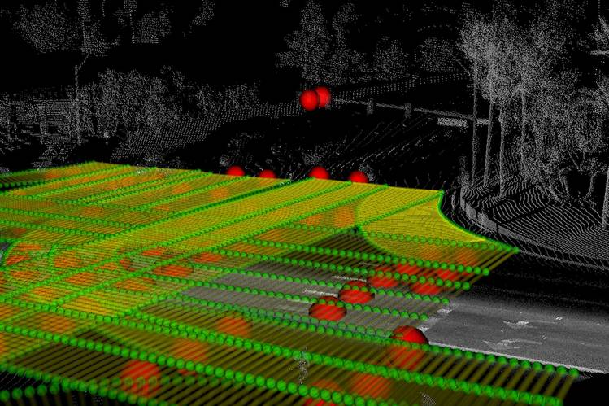
A map used by a self-driving vehicle may include notations about lane width, lane slope and road markings to help the car know what to look for. Red orbs denote things like stop lines, cross walks and road signs. PHOTO: USHR INC.
In urban environments where global positioning systems can be inaccurate, a vehicle must navigate by landmarks, says Sam Abuelsamid, a senior analyst with Navigant research who specializes in mobility. Once a vehicle is navigating using lidar—a 3-D laser view of the environment—along with cameras and possibly radar, it can cross-reference certain buildings, lamp posts or street markings, to identify its stretch of the road down to the centimeter, he adds.
[ Recommended: Why Tesla won't use LIDAR for full self driving cars. (Is this never did, doesn't in 2019, or plans not to in the future?)]
When the car knows precisely where it is, it can follow predetermined routes in its memory, simplifying the driving process. When the Super Cruise system is activated in a Cadillac, the car stays in its lane by following a route that has been determined ahead of time, says Christopher Thibodeau, senior vice president and general manager at Ushr. Ushr makes the Super Cruise system’s maps—terabytes of map data boiled down to a few hundred megabytes of relevant route information.
It’s not quite as if the car is driving on rails, but it’s close. Mr. Thibodeau says it allows the AI in the car to concentrate only on the things in its environment that are changing: cars, pedestrians, unexpected obstacles, construction and the like.
This is especially important because self-driving is already a difficult problem both in terms of the number of sensors it requires and the amount of computing power. A typical fully autonomous self-driving car is drawing 2,000 to 4,000 extra watts of power from its electrical system to operate all of its sensors and computers, Mr. Abuelsamid says.
The car must combine data coming from a variety of sensors—a problem called “sensor fusion” that is an area of intense research—into a single consensus view of reality.
If something goes wrong, the consequences can be dire. Uber Technologies Inc.’s self-driving car killed a pedestrian in March, and more than one Tesla has crashed into the back of a stopped fire truck at highway speeds, apparently while its Autopilot driver-assistance system was on.

Before autonomous vehicles can truly be trusted to operate without human supervision, the computers tasked with driving according to those maps while looking out for unexpected hazards must be much more powerful than those in use today, says Mr. Abuelsamid. Self-driving chips from both Nvidia Corp. and Mobileye are undergoing rapid leaps in computing power, on the order of a tenfold improvement every time these firms release a new iteration.
For Nvidia and Mobileye-owner Intel, this means new opportunities to enter a market that has long been dominated by specialist manufacturers of automotive-grade microchips, such as NXP Semiconductors NV, Mr. Abuelsamid says. But it could also hurt companies that were early to the race to autonomy, such as Tesla Inc.
“Frankly both the sensing and compute capabilities that [Tesla’s vehicles] have today are not capable of providing full self-driving under all conditions, which is what [Chief Executive Elon Musk] said they could do,” says Mr. Abuelsamid. That might change. Mr. Musk has said that Tesla is developing its own AI chip for self-driving, and that it will be a “drop-in” replacement for the existing hardware in its cars. It’s not clear when this replacement computer for Tesla vehicles will arrive. [See https://en.wikipedia.org/wiki/Tesla_Autopilot#Hardware_3.0]
Eventually, Dr. Cummings says, the hope is that all self-driving vehicles will contribute to a collective database that updates in near real-time as roads and conditions change. Mobileye has already promised to create such a database with camera data coming from its partners, including Nissan Motor Co. , Volkswagen AG and BMW AG .
By the end of 2018, Mobileye will be gathering data from three million vehicles’ forward-facing cameras, which will be compiled into a database that will be usable for driver assist and self-driving systems starting in 2019, says Jack Weast, vice president of autonomous vehicle standards at Mobileye.
Others, such as Waymo, are apparently trying to go it alone, since data and algorithms are a huge competitive advantage in the race to fully autonomous driving.
But the cost of such precision mapping sensors at the moment is very high, says Mr. Thibodeau, adding at least $100,000 to the price of each vehicle. These systems will become cheaper, but he believes it will be at least three to five years before they make it onto the kind of vehicles that private citizens could buy, and that it will take many years after that for them to achieve sufficient density on the world’s roadways to contribute to detailed maps suitable for autonomous driving.
How often we re-map all our roads is of critical importance. Ushr’s current database covers about 200,000 miles of controlled-access highways in North America, and even so, the amount of roadway that changes in that database is between 6,000 and 8,000 miles a year, says Mr. Thibodeau.
[Putting the above 2 paragraphs together, only cars with +$100,000 stuff can create or update a collective database today. And about 4% of the database goes bad each year. Finally, little chunks of the database goes bad unpredictably every time an accident, a traffic stop, a fallen bicyclist, a rock slide, a mattres falls onto the highway, or other occurs. "When a Tesla slammed into the back of a stopped firetruck at 60 miles an hour, the driver sued the auto maker, claiming the company misrepresented the capability of its Autopilot software."]
Another challenge for such a system, says Dr. Cummings, is that any central database used by autonomous vehicles would be a prime target for hackers. Not only would a breach have dire consequences, but so would corrupting the map from the outside—in other words, attempting to fool autonomous vehicles by changing things in their environment.
That maps are so critical to self-driving shows, once again, that the road to fully autonomous fleets is longer than we were told—and pushes back the arrival of self-driving cars even further.
Write to Christopher Mims at christopher.mims@wsj.com

